**Aim:**

To study Armstrong Frequency Modulator

**Apparatus:** Scientech ST2208, Connecting Wires, DSO, Probes.

**Theory:**

# FM Transmitter

The audio oscillator supplies the information signal and could, if we wish, be replaced by a microphone and AF amplifier to provide speech and music instead of the sine wave signals that we are using with **ST2208**.

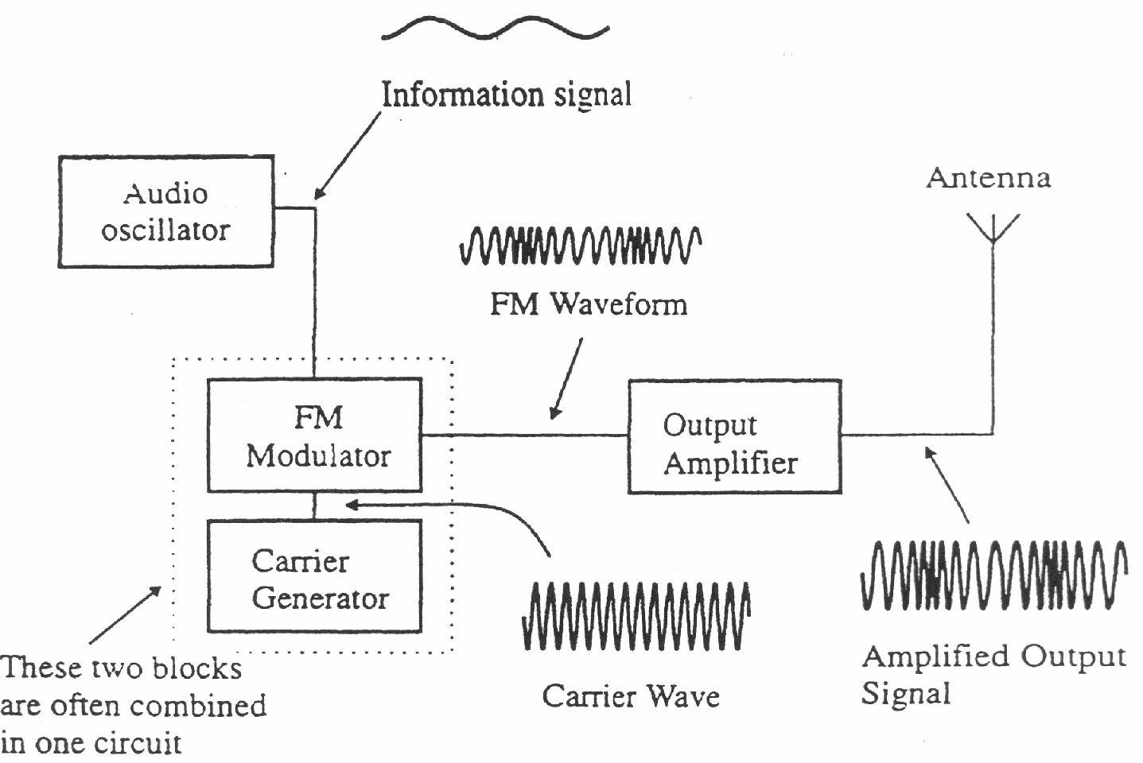The block diagram is shown in Figure below.

# FM Transmitter

The FM modulator is used to combine the carrier wave and the information signal in much the same way as in the AM transmitter. The only difference in this case is that the generation of the carrier wave and the modulation process is carried out in the same block. It is not necessary to have the two processes in same block, but in our case, it is. The output amplifier increases the power in the signal before it is applied to the antenna for transmission just as it did in the corresponding block in the FM transmitter.

# Armstrong Frequency Modulator

A phase – modulated waveform in which the modulating waveform is m (t) is written cos[ωct + m(t)]. If the modulation is narrowband [|m (t)| << 1], then we may use the approximation

cos[ωct +m(t)] = cos ωct – m(t)sin ωct

The term m (t) sin ωct is a DSB-SC waveform in which m(t) is the modulating waveform and sin wct the carrier. We note that the carrier of the FM waveform, that is cos ωct, and the carrier of the DSB-SC waveform are in quadrature. We may note in passing that if the two carriers are in phase, the result is an AM signal since

cos ωct + m(t) cos ωct = [1+m(t)] cos ωct

A technique used in commercial FM system to generate NBFM, which is based on our observation in connection with above equation, is shown in Figure15 Here a balanced modulator is employed to generate the DSB-SC signal using sin ωct as the carrier of the modulator. This carrier is then shifted in phase by 90 degrees and, when added to the balanced modulator output, thereby forms an NBFM signal. However, the signal so generated will be phase-modulated rather than frequency-modulated. IF we desire that the frequency rather than the phase be proportional to the modulation m(t) , then, as discussed in last section and illustrated in Figure we need merely integrated the modulating signal before application to the modulator. . Since the integration of a sinusoidal signal is itself a sinusoidal signal. Hence there is no need to integrate the input message signal. The frequency and the amplitude remain same after integration in case of the sinusoidal signal.

If the system of Figure is to yield an output signal whose phase deviation is directly proportional to the amplitude of the modulating signal, then the phase deviation must be kept small. That such is the case is readily to be seen in Figure If we neglect the small second- order correction in the carrier amplitude and assume it to be of unit magnitude, we have tan φ = Δ1. Since, however, Δ1 is proportional to the modulating signal, we actually require that φ = Δ1.In order that we may replace tanφ with φ, we require that at all times φ<<1. In this case β<<1, and then φ = βsin ωmt

The restriction that β<<1.

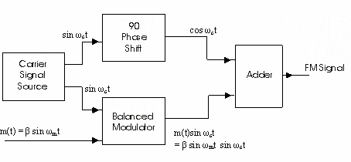

# Armstrong Modulation Technique

The message signal m(t) in above Figure15 and in this experiment is considered as pre-integrated to generate the FM signal at the input of the Balanced Modulator The procedure shown for the generation of the FM is the simplest procedure to generate the Narrow Band FM by Armstrong Modulator.

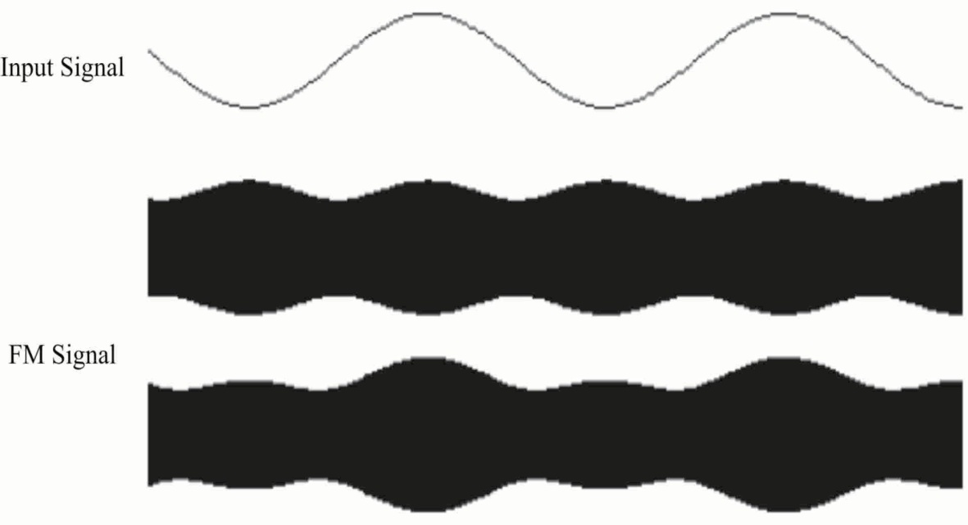

# Armstrong Signal for Frequency Modulation

# Demodulation of FM Signals

A FM receiver is very similar to an AM receiver. The most significant change is that the demodulator must now extract the information signal from a frequency rather than amplitude modulated wave.

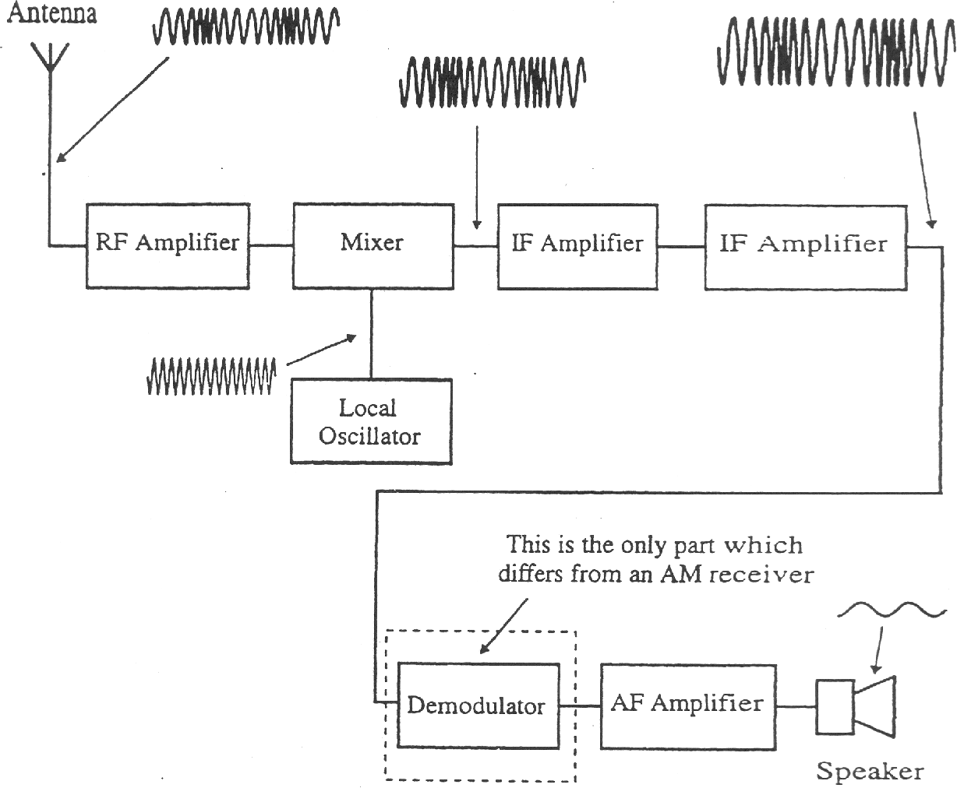

# FM Receiver

The basic requirement of any FM demodulator is therefore to convert frequency changes into changes in voltage, with the minimum amount of distortion. To achieve this, it should ideally have a linear voltage/frequency characteristic, similar to that shown in Figure18. A 'demodulator' can also be called a 'discriminator' or a 'detector'.

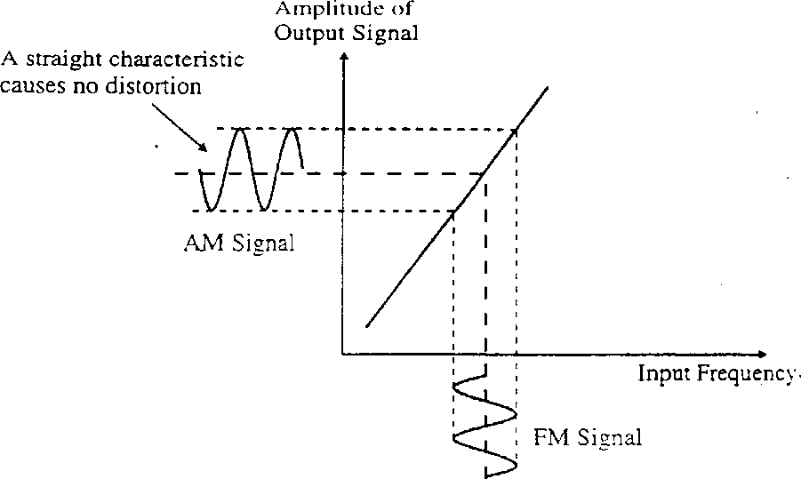

# Transition Relation between FM and AM Modulation

Any design of circuit that has a linear voltage/frequency characteristic would be acceptable and we are point to consider the five most popular types. In each case the main points to look for are :

How do they convert FM signals into AM signals

How linear is their response -this determines the amount of distortion in the final output.

How good are they at rejecting noise signals?

# Phase Lock Loop Detector :

This is another demodulator that employs a phase comparator circuit. It is a very good demodulator and has the advantage that it is available, as a self-contained integrated circuit so there is no setting up required. You plug it in and it works. For these reasons, it is often used in commercial broadcast receivers. It has very low levels of distortion and is almost immune from external noise signals and provides very low levels of distortion altogether a very nice circuit.

# Phase Lock Loop Detector

The overall action of the circuit may, at first, seem rather pointless. As we can see in Figure, there is a voltage-controlled oscillator (VCO). The DC output voltage from the output of the low pass filters controls the frequency of this oscillator. Now this DC voltage keeps the oscillator running at the same frequency as the original input signal and 90° out of phase. And if we did, then why not just add a phase shifting circuit at the input to give the 90phase shift? The answer can be seen by imagining what happens when the input frequency changes - as it would with a FM signal. If the input frequency increases and decreases, the VCO frequency is made to follow it. To do this, the input control voltage must increase and decrease. These change of DC voltage level that forms the demodulated signal.

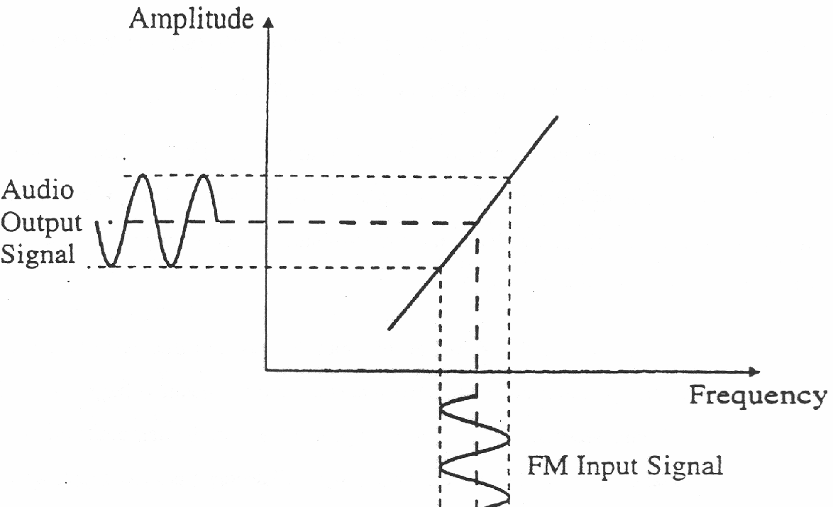

# Frequency Response of VCO

**Procedure:**

This experiment investigates the generation of Frequency Modulated wave using AM (DSB-SC)

1. Repeat the step 1 to 10 of Experiment 1 to generate the DSBSC wave at the output of Balanced Modulator.
2. Short DSB-SC out to the I/P of Buffer Amplifier and then short Buffer Amplifier’s O/P to DSB-SC in of the Op-Amp Adder.

This is the one input of the Op-Amp Adder. The buffer amplifier ensures proper addition of the DSB-SC wave to the other signal. It also isolates the output of Balanced Modulator to the input of the op-amp adder and prevents mixing of the two different frequency signals.

1. Next, Check the cosine out of the 90 degree phase shifter’s output on CRO, to see the exact 90 degree phase shift between sine and cosine wave outputs disconnect the sine Out to carrier in and connect oscilloscopes two channels to sine out and cosine out observe the outputs in XY mode and Dual mode.
2. Now short Cosine out of 90 degree phase shifter to the I/P of Amplitude adjust pot block.

The 90 degree phase shifter convert the sine wave carrier into cosine wave carrier through a integrator it also isolates the Carrier oscillator from op-amps other input (i.e. DSB-SC wave)

1. Check the output of Amplitude adjust block on CRO turn the knob till output goes 5Vpp. i.e. same as the Sine carrier output.

According to the condition of the Armstrong modulator the amplitude of the phase shifted carrier, added to the DSB-SC signal, should be same or nearly same as the original carrier used for the DSB-SC modulation.

1. Short Cosine Out to the Amplitude Adjust blocks I/P and then Amplitude Adjust blocks O/P to the Cosine In of Op-Amp Adder. Make all the connections referring Figure below.

This becomes the other input of the op-amp adder to generate the FM wave.

1. Check the output of Op-Amp Adder at FM Out on CRO.

The phase shifted carrier (Cosine wave) gets Added with the DSB-SC wave of the balanced modulator and generate the Frequency Modulated wave. Using the following approximated relation

cos[ωct +m(t)] = cos ωct – m(t)sin ωct

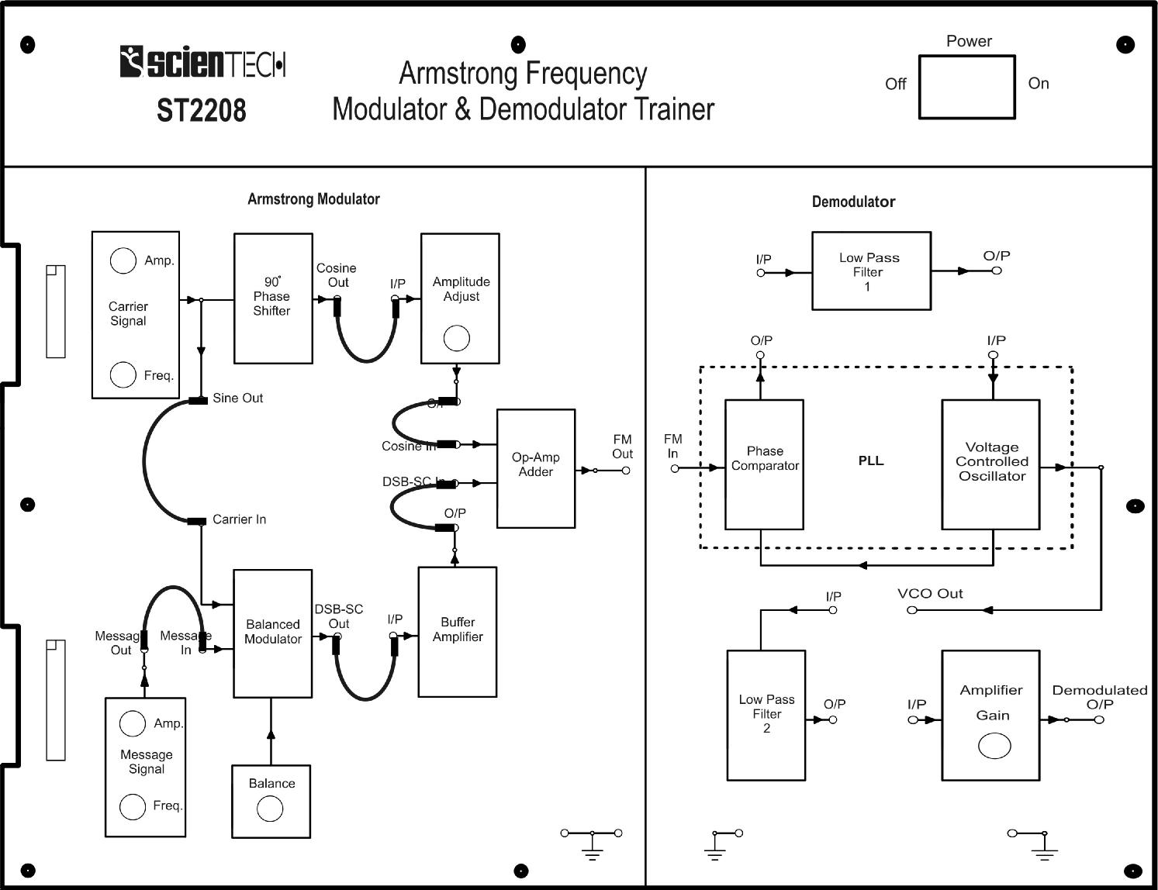

**Setup for Armstrong Modulation Process**

**Conclusion:**

**Post Lab Exercise:**

1. How Armstrong Frequency Modulator works?

# How PLL can be used to demodulate FM wave?